Software Design Specification: Strategic Relationship Audit
Nov 1, 2026 · @Siripod

Overview
Strategic Relationship Audit is a Thai-language, 10-question web assessment that scores a relationship and shows a report immediately, without asking for a name or contact details. It is a single Next.js application backed by one PostgreSQL table.
In scope: the intro page, the quiz, the results report, course recommendations with LINE links, a password-protected statistics page, and a password-protected backoffice with per-question reports and pie charts.
Out of scope: user accounts, online payment, course delivery, and editing questions or courses through a screen. Content changes are code changes.
Layer | Technology | Version
Web framework | Next.js (App Router) | 14.2
UI library | React | 18.3
Language | TypeScript | 5.5
Styling | Tailwind CSS | 3.4
Icons | lucide-react | 0.400
Database driver | node-postgres (pg) | 8.12
Database | PostgreSQL | 13 or newer, tested on 17.5 and 18.6
Runtime | Node.js | 18.17 or newer; Netlify builds use 22

Architecture
The system is a three-tier monolith: the browser, one Next.js server, and one PostgreSQL database. There are no background jobs, caches or external services at run time. Google Fonts files are downloaded once, at build time.
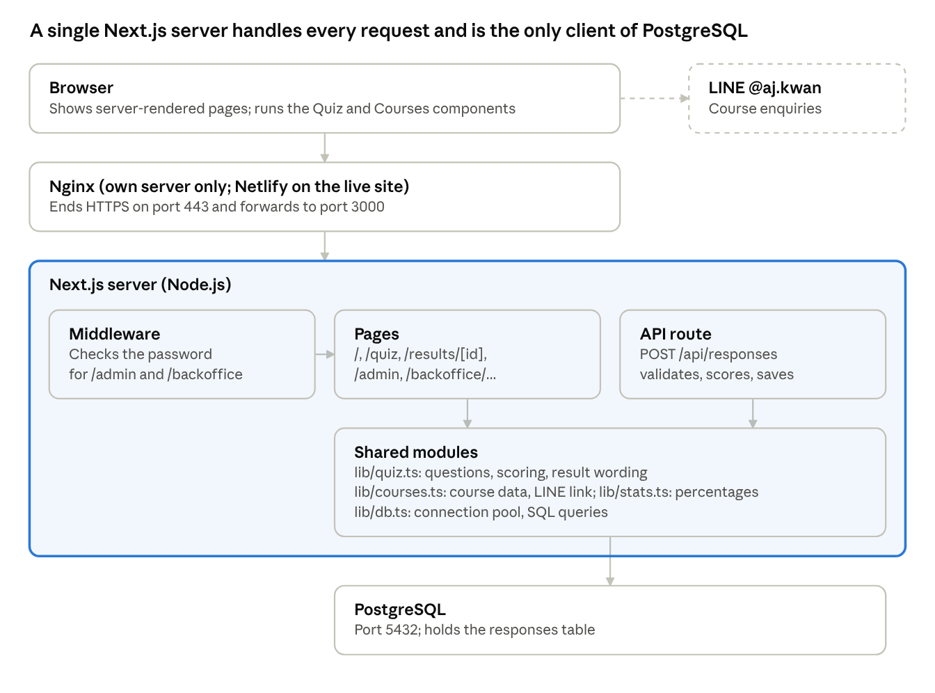
System architecture · production deployment
The dashed LINE box is a plain link the visitor opens; the server never calls LINE.

Request flow: completing the quiz
- The browser loads /quiz, and Quiz.tsx holds the answers in memory.
- On the last question, the browser sends POST /api/responses with the 10 answers.
- The server validates the answers, calculates the scores and inserts one row.
- The server returns the new UUID, and the browser goes to /results/{id}.
- The results page loads answers from the database, recalculates the result and renders the report on the server.

Code structure
Path | Contents
app/ | Pages, layout, global CSS and the API route
app/backoffice/ | Backoffice layout, report page and charts page
components/ | Quiz.tsx, Courses.tsx, PieChart.tsx
lib/ | quiz.ts, courses.ts, stats.ts, db.ts
db/schema.sql | Table and index definition
scripts/ | migrate.mjs applies the schema; dev-db.mjs runs a local development database
middleware.ts | Password check for /admin and /backoffice

Key design decisions
Decision | Reason
Keep questions and courses in code | They change rarely, and no editing screen is in scope
Score on the server | Stored results stay consistent regardless of what the browser sends
Use pg with plain SQL, no ORM | One table with a few queries does not need one
Use a UUID as the report ID | Report links cannot be guessed by counting
Build dev and production into separate folders | next dev crashes in the browser if it reuses next build output, so dev uses .next-dev

Security and privacy
Topic | Current design
Personal data | No names, contact details or IP addresses are stored by the app. Answers are still sensitive, and Nginx access logs do record IP addresses
Report access | Anyone with a report's link can open it, with no login
SQL injection | All queries use bound parameters
Admin and backoffice access | HTTP Basic authentication, which is safe only over HTTPS
Rate limiting | None in the app, so the public API could be flooded
Data retention | None; rows are kept until someone deletes them

Cloud deployment
The live site runs on Netlify with its database on Neon, at strategic-relationship.netlify.app. This replaces Nginx and the Ubuntu server in the diagram above; the application code is the same.
Part | Service | Setup
Web app | Netlify, free plan | Deploys from the main branch of siripods/relationship-audit, configured by netlify.toml
Pages and API | Netlify Functions | One server function handles pages and the API
Password check | Netlify Edge Functions | middleware.ts runs before the page is served
Database | Neon, free plan | Project relationship-audit, Siripod organization, Singapore (aws-ap-southeast-1), PostgreSQL 18.6
Settings | Netlify environment variables | DATABASE_URL (Neon pooled string) and ADMIN_PASSWORD; never stored in Git
Schema changes | Netlify production build | Runs npm run db:migrate before each live build
Serverless hosting and a database that sleeps led to these connection settings in lib/db.ts.
Setting | Value | Reason
Connection string | Neon pooled | Many short-lived function copies share Neon's connection pooler
max | 3 | Each copy holds few connections
idleTimeoutMillis | 10,000 | Releases idle connections soon
connectionTimeoutMillis | 15,000 | Allows time for Neon to wake after suspending
Pool error listener | Logs the error | A dropped idle connection would otherwise crash the process
Neon suspends after 5 minutes without activity, so the first database request afterwards is slower. Each push to main starts a deploy that uses 15 of the free plan's 300 Netlify credits, and traffic uses the same credits.

Environment variables and configuration
The app reads two environment variables, DATABASE_URL and ADMIN_PASSWORD. Everything else is fixed in configuration files stored in Git, and secrets are never stored there.

Environment variables
Variable | Required | Read by | Purpose | If missing or wrong
DATABASE_URL | Yes | lib/db.ts, scripts/migrate.mjs | PostgreSQL connection string, which includes the database password | db:migrate stops with an error; a Netlify production build fails; saving a response and database pages fail
ADMIN_PASSWORD | Yes, for /admin and /backoffice | middleware.ts | Login password; the username is always admin | Those pages return 503 and stay locked; public pages keep working. A wrong value returns 401
NODE_VERSION | Netlify only | Netlify build | Node.js version for builds, 22, set in netlify.toml | Netlify uses its default version
The Neon CLI also writes DATABASE_URL_UNPOOLED and NEON_BRANCH to a local .env. The app does not read them.

Where values are set
Environment | Location | DATABASE_URL value | Notes
Local development | .env in the project folder, ignored by Git; copy from .env.example | Local PostgreSQL, or Neon if linked with the Neon CLI | Restart the app after changing it
Netlify | Project configuration > Environment variables | Neon pooled connection string | Deploy again after changing a value
Own Ubuntu server | /opt/relationship-audit/.env, file mode 600 | localhost PostgreSQL | Restart the service after changing it
On Netlify, each variable needs a Production value, and ADMIN_PASSWORD needs a scope that includes Functions, because the password check runs as an edge function. Do not put either variable in netlify.toml: that file is in Git, and Netlify does not pass its variables to edge functions.

Configuration files
File | In Git | Purpose
.env.example | Yes | Template for .env, with no real secrets
.env | No | Local settings and secrets
netlify.toml | Yes | Build command, Node version, and db:migrate on production builds only
next.config.mjs | Yes | Separate build folders for dev and production; keeps pg out of the bundle
middleware.ts | Yes | Which paths need a login: /admin and /backoffice
package.json | Yes | Scripts and dependency versions
tailwind.config.ts, postcss.config.mjs | Yes | Brand colours, fonts and CSS processing
tsconfig.json | Yes | TypeScript rules and the @/ import path
docker-compose.yml | Yes | Optional local PostgreSQL 17, with development-only credentials
.gitignore | Yes | Keeps .env, .neon, node_modules and build output out of Git
.neon | No | Links a local folder to the Neon project
Database connection pool values are set in lib/db.ts, not through environment variables; the Cloud deployment section explains them. Course data and the LINE link are in lib/courses.ts, so changing them requires a new deploy.

Handling secrets
- Use a long, unique ADMIN_PASSWORD. Thai characters work, and a colon is allowed.
- If the database password or ADMIN_PASSWORD is exposed, change it at the source and deploy again.
- The development values in .env.example and docker-compose.yml must not be used in production.

Database design
The database has one table, responses, with one row per completed quiz. It stores no name, contact details or IP address.

ER diagram
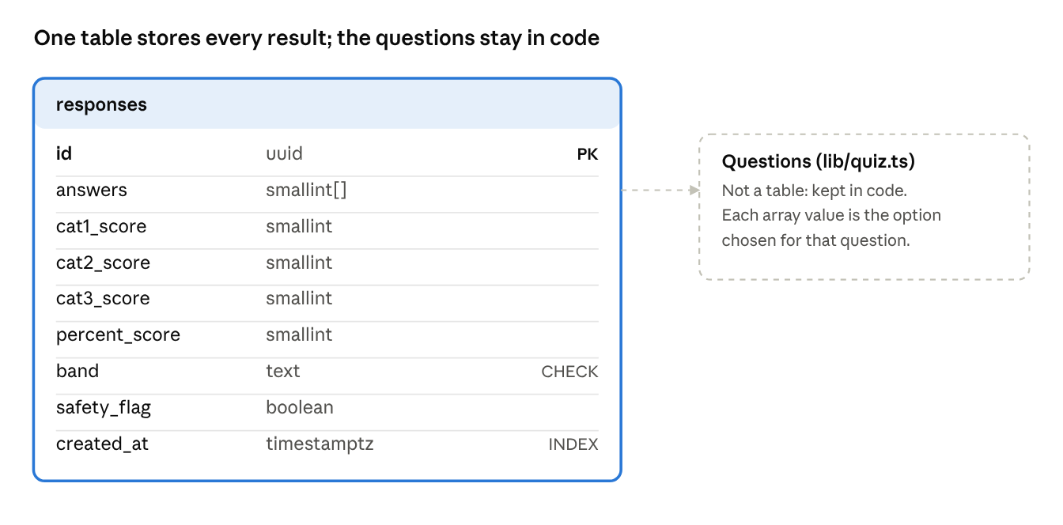
ER diagram · 1 table, no foreign keys
There are no relationships to draw between tables, because questions and courses are stored in code. The dashed box shows the one logical link: the answers array refers to questions by position.

Schema definition
The schema is in db/schema.sql, and npm run db:migrate applies it. It can safely run more than once.
CREATE TABLE IF NOT EXISTS responses (
id uuid PRIMARY KEY DEFAULT gen_random_uuid(),
answers smallint[] NOT NULL,
cat1_score smallint NOT NULL,
cat2_score smallint NOT NULL,
cat3_score smallint NOT NULL,
percent_score smallint NOT NULL,
band text NOT NULL CHECK (band IN ('critical', 'warning', 'safe')),
safety_flag boolean NOT NULL,
created_at timestamptz NOT NULL DEFAULT now()
);
CREATE INDEX IF NOT EXISTS responses_created_at_idx ON responses (created_at DESC);

Table definition: responses
Column | Type | Null | Default | Description
id | uuid | No | gen_random_uuid() | Primary key, also used in the report link
answers | smallint[] | No |  | 10 option indexes in question order: 0 red, 1 yellow, 2 green
cat1_score | smallint | No |  | Safety and boundaries, 0 to 6
cat2_score | smallint | No |  | Core life values, 0 to 6
cat3_score | smallint | No |  | Skills and style, 0 to 8
percent_score | smallint | No |  | Overall score, 0 to 100
band | text | No |  | critical, warning or safe
safety_flag | boolean | No |  | True if any of questions 1-3 got the most severe answer
created_at | timestamptz | No | now() | When the quiz was submitted

Index or constraint | Definition | Purpose
responses_pkey | Primary key on id | Loads a report by its link
responses_created_at_idx | created_at DESC | Lists the latest results on the admin page
Band check | band IN ('critical', 'warning', 'safe') | Rejects unknown band values
The report page recalculates its result from answers, so changes to wording or scoring apply to old reports too. The score, band and flag columns keep the values from submission time and feed the admin statistics. Rows are kept indefinitely; there is no automatic deletion.

Statistics query and the answers column
The backoffice counts answers by expanding the answers array into one row per question, so the array column needs no schema change.
SELECT a.question_no::int AS question_no,
a.option_index::int AS option_index,
count(*)::int AS picks
FROM responses r
CROSS JOIN LATERAL unnest(r.answers) WITH ORDINALITY AS a(option_index, question_no)
GROUP BY a.question_no, a.option_index;
The array was compared with a separate table holding one row per answer, using 100,000 random test responses on a local PostgreSQL 17.5 server.
Design | Time to count all answers (ms, best of 3) | Disk space
Array column (current) | 133 | 16 MB for the whole table
Separate answers table, with an index | 125 | 57 MB extra
A separate table would be faster only for queries that read a small part of the data, which the backoffice does not do.
Known limit: answers link to questions by position only. Rewording or reordering a question changes what stored answers appear to mean, in statistics and in old reports. If questions will change, add a question version to each response first.

Frontend design
The frontend has seven routes. Only the quiz and the course list run React in the browser; everything else is rendered on the server.

Pages
Route | File | Rendering | Purpose
/ | app/page.tsx | Static | Intro, the three categories, start button
/quiz | app/quiz/page.tsx | Static shell, client component | One question at a time, with a progress bar
/results/[id] | app/results/[id]/page.tsx | Server, on each request | Score, category cards, guide, helplines or courses
/admin | app/admin/page.tsx | Server, on each request | Totals and the 50 latest results, behind a password
/backoffice | app/backoffice/page.tsx | Redirect | Sends the visitor to the report, behind a password
/backoffice/report | app/backoffice/report/page.tsx | Server, on each request | For each question: picks and percentage per answer, behind a password
/backoffice/charts | app/backoffice/charts/page.tsx | Server, on each request | For each question: a pie chart and legend, behind a password
The results, admin and backoffice pages are marked noindex so search engines do not list them.

Components and shared modules
Name | Type | Responsibility
app/layout.tsx | Server component | Header, footer, LINE link, Kanit and Prompt fonts
app/backoffice/layout.tsx | Server component | Backoffice navigation between report and charts
components/Quiz.tsx | Client component | Current question, answers, submit, error message
components/Courses.tsx | Client component | Course cards and the details popup
components/PieChart.tsx | Server component | Draws one question's pie chart as SVG, with no chart library
lib/quiz.ts | Shared module | Questions, scoring, all result wording
lib/courses.ts | Shared module | Course data and the LINE URL
lib/stats.ts | Shared module | Turns answer counts into per-question totals and percentages; chart colours
lib/db.ts | Server module | Connection pool and SQL queries

State
All quiz state lives in Quiz.tsx as React state: the question index, an array of 10 answers, a submitting flag and an error flag. Nothing is saved until the last question is submitted, so reloading the page mid-quiz starts over. After submission the report is loaded by its URL, so it survives reloads and can be reopened from the link.

Scoring rules
Each answer scores 0, 1 or 2, and option order is fixed as red, yellow, green. The total is out of 20 and is shown as a percentage.
Measure | Red or critical | Warning | Healthy or safe
Overall percentage | Below 50 | 50 to 79 | 80 or above
Category ratio (score / maximum) | Below 0.5 | 0.5 to 0.79 | 0.8 or above
Category maximums are 6 for questions 1-3, 6 for questions 4-6 and 8 for questions 7-10.
Safety override: the most severe answer on any of questions 1-3 sets safetyFlag. The report is then always critical, whatever the total, and category 1 shows Red Flag. It adds helplines 1300, 1323 and 191 and hides the courses and consultation offer.

Visual design
Element | Specification
Theme | Dark, with pink accents
Background and cards | #0b0b0f, #12121a
Border | #262636
Accent colours | Pink #ff2a85, rose gold #e8a5b8, gold #d4af37
Fonts | Kanit for headings, Prompt for body text
Layout | Single column on phones; category and course cards become 3 columns from 768 px
Popup | Rendered into document.body, because a card's blur effect would otherwise trap it off screen

Backoffice
The backoffice reads every completed response and shows the same statistics two ways: as tables on the report page and as pie charts on the charts page. Each page loads fresh data on every request.
Item | Rule
Percentage | Picks for an answer / total responses for that question x 100, shown to 1 decimal place
Answers nobody picked | Listed with 0 picks and 0.0%, with no slice on the chart
An answer picked by everyone | Drawn as a full circle
No responses yet | The report shows zeros; each chart area shows a no-data message
Chart colours | Severe #ef4444, moderate #d19a08, good #14a090, in that order
Reading without colour | Each slice has a legend entry with its level, answer text, percentage and count
Hover | Each slice shows its answer, count and percentage as a browser tooltip
The colours pass a colourblind separation check against the dark card background. The moderate colour sits slightly above that check's preferred lightness range, which the legend labels offset.

API design
The application exposes one JSON endpoint, which saves a completed quiz and returns the new result's ID. Reports and statistics are server-rendered pages, so they need no API of their own.

POST /api/responses
Property | Value
Authentication | None, the quiz is public
Request type | application/json
Handler | app/api/responses/route.ts
Request body: answers must be an array of exactly 10 integers, each 0, 1 or 2, in question order.
{ "answers": [2, 2, 1, 2, 1, 2, 2, 1, 2, 2] }
Success response, 201 Created:
{ "id": "e6757cc4-e79e-4913-969e-ed5c05109a20" }
The client then navigates to /results/{id}.
Status | When | Body
201 | The response was saved | { "id": "<uuid>" }
400 | Invalid JSON, wrong array length, or a value other than 0, 1 or 2 | { "error": "Invalid answers" }
500 | The database is unavailable or the insert fails | Next.js default error; the quiz shows a retry message
The server calculates all scores itself. Scores sent by a client would be ignored, since the endpoint reads only answers.

Page access
Request | Result
GET /results/{id} with an existing UUID | 200, the report
GET /results/{id} with an unknown or malformed ID | 404
GET /admin with the right credentials | 200, the statistics
GET /backoffice with the right credentials | 307, redirect to /backoffice/report
GET /backoffice/report or /backoffice/charts with the right credentials | 200, the page
/admin or /backoffice pages with missing or wrong credentials | 401 with a WWW-Authenticate header

Admin and backoffice authentication
middleware.ts protects /admin, /backoffice and everything under them with HTTP Basic authentication. The username is admin and the password comes from ADMIN_PASSWORD. If that variable is empty, these pages return 503 with a message naming the missing setting, and stay locked. Credentials are read as UTF-8.

